Tekla-AutoCAD Interop Documentation
Command: ConvertToTekla
What does it do?
- It maps AutoCad entities directly to Tekla. It is capable of creating: (i) Tekla Beams and Columns, (ii) PolyBeams, and (iii) Contour plates.

AutoCAD Entity | Tekla Entity
BlockReference (must be on “COL” starting layer) | Columns (Beam)
Lines | Beams (Beam)
Polyline (closed) | Contour Plate
Polyline (open) | PolyBeam
BlockReference (xref) – must be on “XREF” starting layer | Reference Model

Copyright Warning:
- WARNING: Property of Ben Koshy for use by Tek1 employees and affiliated entities. Do not pirate this software – if caught you will be prosecuted to the fullest extent of the law.

Instructions:
- You must have Tekla open, and you must have a model open before running.
- You must only have one model open.
- Known bugs: You should save before running otherwise it might come up with an error saying that the .csv file could not be found. But please check your spelling.
- WARNING: Polylines with arcs: all polylines with arcs should have straight lines immediately surrounding both ends of any arc segment. When this happens the node will be at the intersection of the two tangents of the arcs. Otherwise, the node will be directly on the polyline curve. If you do not follow this rule then results may be unexpected.
- Correct CSV entries must be used in the CSV file.
- If there any errors – it will fail silently and you will not know or be notified, so please be careful.
- Make sure that the beams you create, or the lines you create in AutoCAD have a tangible length. IF you create a line which has a length of 0, then it will just skip this.

UCS Rules:
- Members will be transported from AutoCAD’s UCS to Tekla’s UCS. Make sure you set the UCS of both program/models correctly.

Beam Rules
- Draw lines or polylines on the layer of the membermark and run the command.

Column Rules
Columns are referenced as Blocks in Autocad:
- Column block start with: “COL” and have the following attributes:
  - MEMBERMARK
  - TOPRL
  - BOTTOMRL.
- For example: You can have a column block starting with “COL-PFC” or “COL-SHS”.
- Important: If you have a COL-SHS block for example, but you specify a PFC in the profile, then the program will assume that you want to create a PFC column – and will adjust the rotation accordingly. Please be very clear on this point.

Default Values for Columns (i.e Blocks):
- For columns, whatever you put on the CSV file is effectively ignored. The following default values are used instead.
- If the column is a PFC, as determined by the profile noted in the CSV file, then these are the following default values we interpret, regardless of what the CSV file contains:
Column PFC Defaults:
- Plane: "MIDDLE"
- PlaneValue: 0
- Depth: “LEFT”
- DepthValue: 0
- Rotation: “FRONT”
- RotationValue – this is read from the AutoCAD column block and no default is supplied. Please ensure that the block definition is set correctly.

Column NonPFC Defaults:
- Plane: "MIDDLE"
- PlaneValue: 0
- Depth: “MIDDLE”
- DepthValue: 0
- Rotation: “FRONT”
- RotationValue – this is read from the AutoCAD column block and no default is supplied. Please ensure that the block definition is set correctly.

Test: Quiz: Did you understand what was above?
- Raghu sets up the CSV file as below. Let us focus on the SC3 member. It is a PFC.

Questions: Column PFC – Quiz 1
- By looking at the CSV file alone and nothing else – will SC3 be a line (beam) or a block (column) in AutoCAD?
- Let’s assume that Raghu intends SC3 to be a column. What type of AutoCAD entity must he draw in AutoCAD?
- Raghu draws the column block on the SC4 layer in AutoCAD. But he specifies, in the block, the membermark as being SC3. What profile will be drawn in Tekla?
- Raghu draws a block in AutoCAD. Note that he wants the plane to be “FRONT” as he specified in the CSV file. What will the plane of the PFC be in Tekla when it is drawn?
- Raghu creates a block without an attribute called “MEMBERMARK” – will it work if he wants to convert a column into Tekla?
- Raghu decide to name his column block “COLUMN”. Will the code still work?
- Raghu decides to name the column block “PFC-COLUMN”. Will the code still work?
- Someone draws a line in AutoCAD of length 0.2. Will this be converted? What if someone draws a line which is 0.01 – will it be drawn?

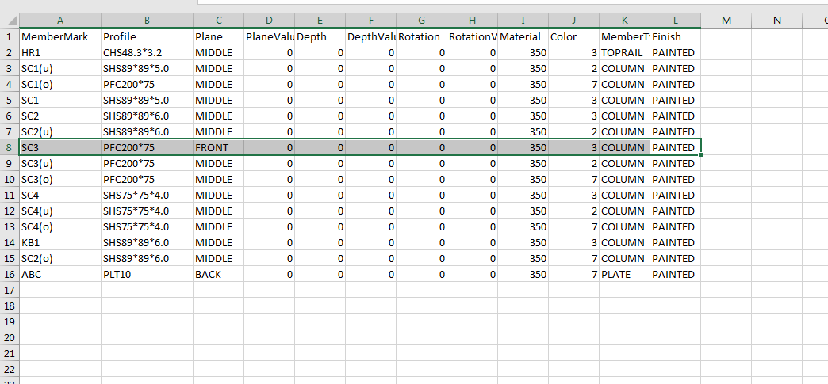

Answers:
- This is a trick question. We cannot tell what type of AutoCAD entity SC3 maps to. It could be a column. It could also be a beam. It could be an AutoCAD line, or an AutoCAD block.
- If he wants a column he must draw a block in AutoCAD.
- The layer name of blocks (columns) are irrelevant. The code will look at the block’s attributes – and see what the member mark says. If the member mark says “SC3” then the profile will be a PFC200*75 and NOT SHS75*75*4.0.
- Because Raghu is dealing with a column (block) then the values entered in the CSV file will be ignored and will resort to the default values. Since we are dealing with a PFC then these values will resort to the default values listed above. Consequently the plain that can be expected for SC3 in Tekla will be MIDDLE and NOT “FRONT”.
- If Raghu does not specify a MEMBERMARK attribute then it will fail and throw an error.
- Yes the code will still work because “COLUMN” starts with “COL”.
- The code will fail if he names the block: “PFC-COLUMN”. Because the block doesn’t begin with “COL”.
- Lines less than 0.1 in length will not be drawn.

Question: Column NonPFC – Quiz 2
Raghu now decides he wants to model SC4.

Questions:
- If SC4 is represented as a block in AutoCAD (with all the correct tags and attribute values) then what can he expect the column’s plane to equate to in Tekla?

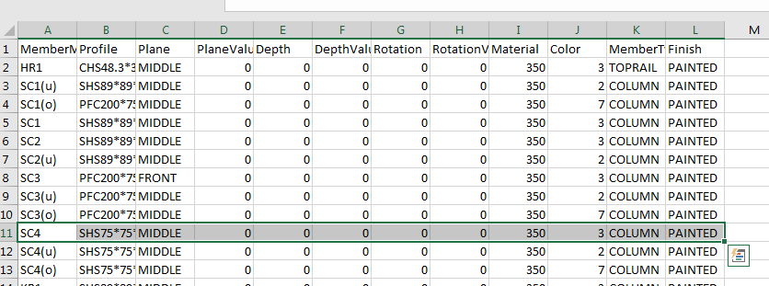

Answer:
- Because we are dealing with a column, that is a non-PFC column, then the plane will default to the values noted above: it will default to “MIDDLE” regardless of what is written in the CSV file.

XRef Rules:
- All external references must be on a layer starting with “XREF”.
- All the Xrefs must be

.csv File Rules:
- .csv file must be named: “MEMBER-SCHEDULE.csv” with the following:
  - MemberMark
  - Profile
  - Material
  - Color
  - MemberType
  - Finish
- You must correctly note the profile so that Tekla will understand. If you write an incorrect member profile: e.g. UWKE150*23*J3 then you will get an error.
- Everything must be comma separated.
- Omit quotation marks.

Example of CSV file:
Do not touch this line!
MemberMark, Profile, Plane, PlaneValue, Depth, DepthValue, Rotation, RotationValue, Material, Color, MemberType, Finish
- Must save as .csv (not .txt).
- DO NOT USE NOTEPAD or WORD to create your .csv file. You must use Excel or open office. Save as a .csv file. If confused then please google “how to create a .csv file”.

Help! I have an error! Possible Trouble Shooting – Please check before calling:
Before contacting support, please make sure that the documentation is being complied with:
- Is the CSV input valid? For example you cannot have “ABC” in a column which is for numbers. You cannot have “ABCD” for the profile. You cannot have missing member marks. Please check that the CSV input is valid before contacting support.
- Is there a member mark in the CSV file?
- Are the beams on a layer corresponding to a member mark?
- Have you got the right UCS?
- Is the Profile correct? If you write: SDFDLJ9*#2342 then it will throw an error. Are there missing commas in the CSV file? Are the headings spelt correctly?
- Have you saved the AutoCAD file? Sometimes it fails and if you save the AutoCAD file again it will run.
- Is the CSV file in the right location?
- Are the attributes existing in the block?
- Does the block start with “COL”?
- How many versions of Tekla do you have open?
- Do you have Tekla Open.
- Is the CSV file and the drawings saved in the same location?
- Are the lines you created in AutoCAD of zero length?
- Do you have lines duplicated in AutoCAD (two lines that are exactly the same over each other)?

